The University of Azad Jammu and Kashmir, Muzaffarabad

Name: Alishba Zakir
Roll No: 2024-SE-02
Course: Computer Networks
Course Code: SE-2203
Lab: Router -CLI (2)
Submitted To: Engr. Dr. Asma Javaid
Submitted By: Alishba Zakir
Date: 24 April, 2026

Department Of Software Engineering
Router -CLI
Objective :
The primary goal of this lab is how to connect to networking devices (like routers and switches) and configure them using the Command Line Interface (CLI). Specifically, s will learn to:
Connect hardware using console ports and cables.
Navigate different Cisco IOS modes (User, Privileged, and Global Configuration).
Apply basic security settings and manage configuration files.
Enable :
Used to move from User EXEC mode to Privileged EXEC mode, which allows for advanced access and monitoring.

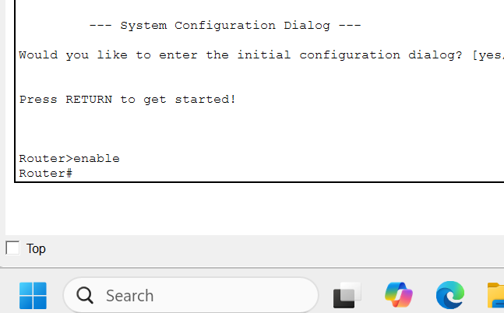
Configure Terminal :
Used to enter Global Configuration mode from Privileged EXEC mode to change device settings.
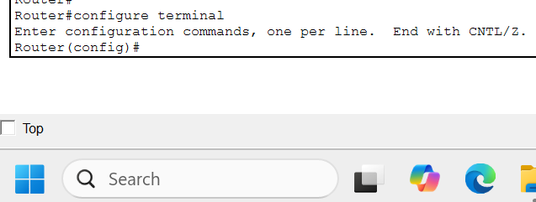

Enable password cisco :
Sets a password to restrict access to the Privileged EXEC mode.

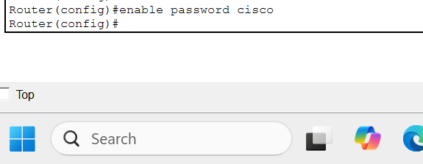
Service password-encryption :
Encrypts all plain-text passwords (like the enable password) within the configuration file.

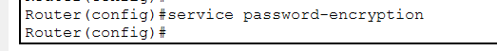

Enable secret class :
Sets a secure, encrypted password for entering Privileged EXEC mode, providing better security than the standard enable password.

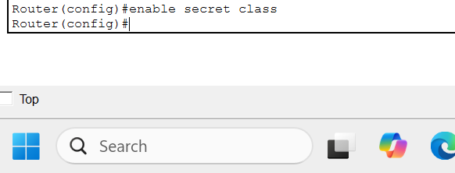

End:
Immediately return to Privileged EXEC mode (the Router# prompt) regardless of which configuration sub-mode you are currently in.
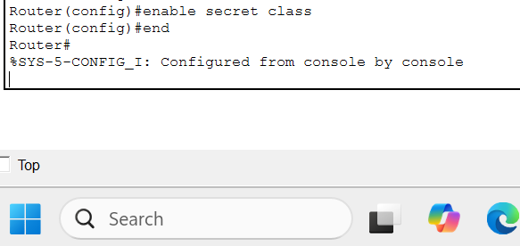
Do show running -config :
Displays the active configuration currently stored in the device's RAM.

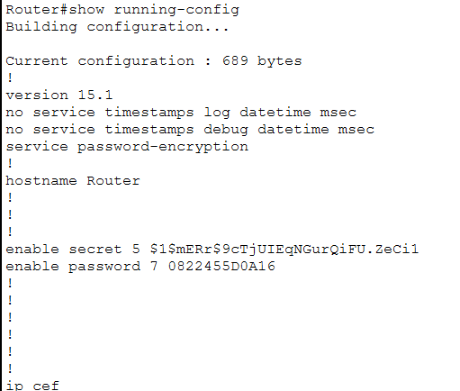

Do show startup-config :
Displays the saved configuration stored in the NVRAM, which is used when the device boots up.

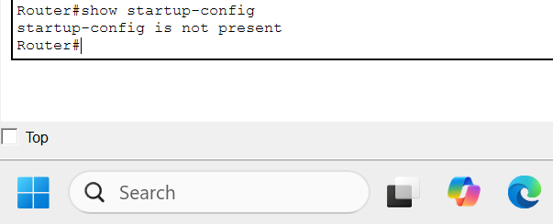

Copy running-config startup-config :
Saves the current active configuration to NVRAM so that changes are not lost after a reboot.

